Director of Philanthropy and Fundraising

New York, NY/Remote | Summer 2022

Tracy Marshall
senior VICE PRESIDENT, PRINCIPAL
Development Guild DDI
tmarshall@developmentguild.com
617 277-2112, ext. 251

developmentguild.com
BOSTON | NEW YORK

Religions for Peace seeks a strategic, visionary, and mission-driven Director of Philanthropy and Fundraising to significantly grow philanthropy in support of its global mission and vital programs.
About Religions for Peace
Religions for Peace is a global not-for-profit organization of all faiths comprising 90 national and six regional Interreligious Councils with vast influence and resources of all faith traditions.

Religions for Peace is a worldwide movement to help change the world and challenge the status quo through a mutual conviction that religions are more powerful, inspiring, and impactful when they work together. The organization sees the world’s challenges and understands the benefits of an interfaith, innovative, and inclusive response. As a movement, Religions for Peace works at local, national, regional and global levels as changemakers, responding to human challenges—from violence and discrimination to environmental degradation—with bold solutions that ensure the advancement of humanity, leaving no one behind.

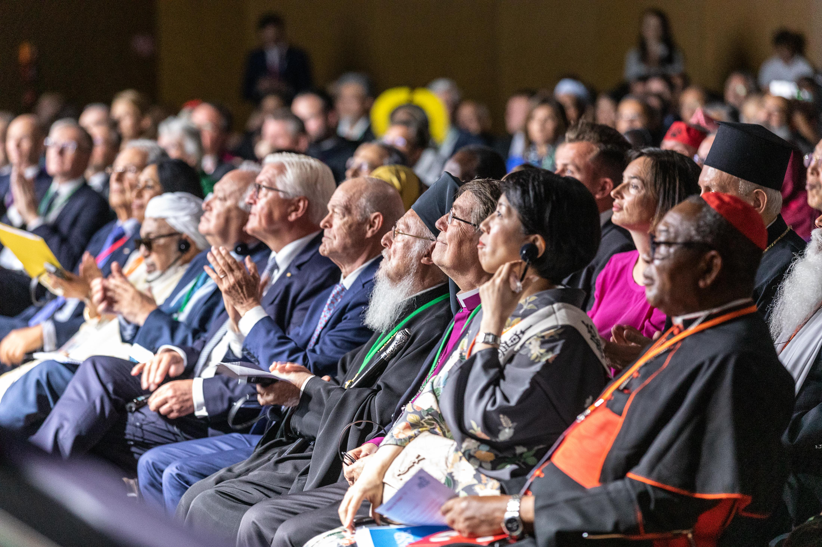
Through more than five decades of learning from its interreligious platforms and multi-religious collaboration, Religions for Peace has experienced religion contributing to solutions, but has also witnessed “religion” being responsible, in diverse ways, for contemporary challenges that all too often disproportionately affect the vulnerable, including the poor, refugees, internally displaced persons and minorities. Of special concern is the fact that religion is misused in support of violent conflict and extremism – exacerbated by the rising tide of hostility among social groups, including religious communities. Space for civil society has been shrinking, eroding the foundations of democracy and respect for human dignity. Therefore, it is critical to ensure that religions (actors and institutions) are engaged through multi-religious collaboration in all processes of development, human rights, and peace and security.

Bearing in mind these challenges and the urgent need for a strong global network of interreligious bodies to lead efforts advancing effective multi-religious cooperation, in 2020, Religions for Peace launched its current Strategic Plan. The plan reflects the priorities of the world’s faith communities and its alignment with the United Nations Sustainable Development Goals (SDGs). The six priorities outlined in the plan that guide the work of Religions for Peace are:

- Peaceful, Just, and Inclusive Societies – Faith traditions inspire changemakers where conflict, mass displacement, poverty, violent extremism, and inequality call for common action.
- Gender Equality – Equality for women and girls is a foundation for securing a more peaceful and inclusive world for all people.
- The Environment – Recognizing the intimate connection between all forms of life and communities, Religions for Peace is committed to nurturing a sustainable environment.
- Freedom of Thought, Conscience, and Religion – Everyone has the right to freedom of thought, conscience, and religion. Religions for Peace brings faith communities together to champion this right for all.
- Interreligious Education – Understanding diverse traditions is vital to increasing trust, respect, and cooperation among all people and faiths.
- Global Partnerships – Strong partnerships with governments, civil society, and faith-based organizations ensures that the work of Religions for Peace is effective and leaves no one behind.
About Philanthropy at Religions for Peace
Philanthropy at Religions for Peace has been growing steadily to its current annual budget of approximately $3-5 million. Given the current and critical state of a world still emerging from years in the pandemic and amid ongoing political turmoil, there is tremendous opportunity and urgency to build and grow resources to drive the impactful programmatic and advocacy work of Religions for Peace.

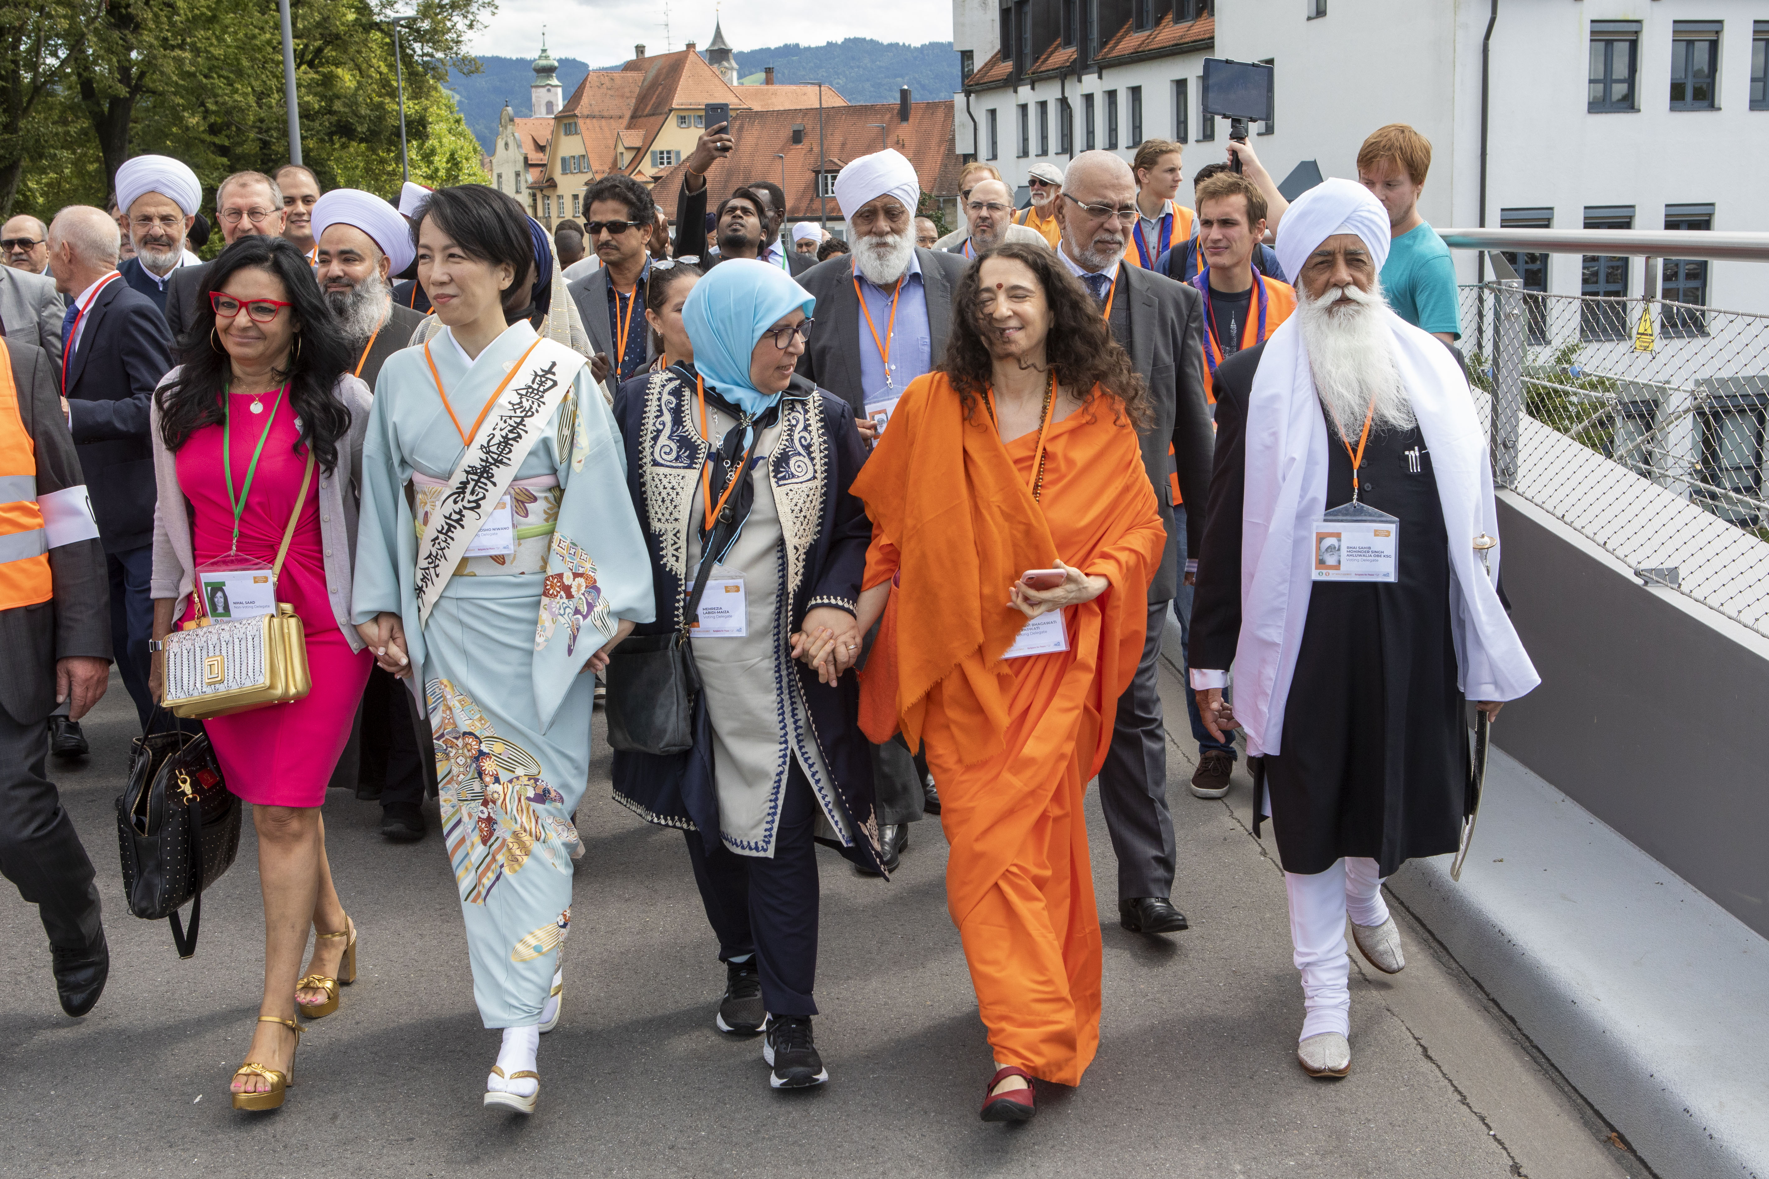
Since its establishment in 1970, the organization has been guided by a vision of a world where faith communities cooperate effectively for peace and harmony. Religions for Peace advances common action so the world can hear unheard voices. In times of need and crisis, Religions for Peace can often be more present and effective through specific organized programs across the globe. The organization provides a space for people of faith living side by side to work together.

In response to the pandemic and guided by its strategic priorities, Religions for Peace gathered the resources needed to equip and spearhead multi-faith responses to the crisis by launching the first Multi-religious Humanitarian Fund. This fund brought religious actors together—multi-religiously—to work side by side in humanitarian service.

THE FUND IN ACTION
On a cloudless day in northern Albania, a small delivery truck came to a halt in a dusty field. It had arrived just in time and with much needed supplies – the country had been struck by a catastrophic earthquake, leaving broken homes, destroyed families, and orphaned children in its wake. Following closely on
its heels was the COVID-19 outbreak. Standing shoulder-to-shoulder in that field that day was a Muslim schoolteacher and a Catholic nun. Together, they hoisted boxes off the back of the truck, surrounded by the orphaned children and widowed parents those supplies were meant to help.

From behind the dim glow of a computer screen, a young Muslim student in the Philippines began her own fight against COVID-19. Enlisting the help of her Christian and Buddhist friends, they messaged houses of worship, working with religious leaders identified families struggling to provide for themselves, and organized the delivery of hundreds of emergency food boxes.

Though forged during the COVID-19 pandemic, the Multi-religious Humanitarian Fund was built from the start to outlast the pandemic. The Fund—one example of the tangible impact of Religions for Peace—is intended to support diverse religious communities to work together in their frontline efforts to respond to communities facing humanitarian crises.
About the Position
Reporting to the Secretary General, the Director of Philanthropy and Fundraising will serve as a visible and important contributing member of the Senior Management Team.
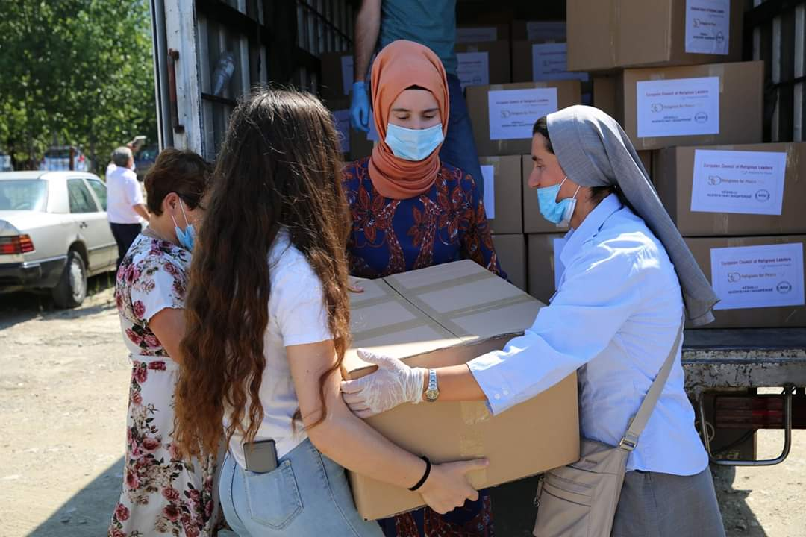
Working in close partnership with the Secretary General, a diverse and international Board, and highly accomplished colleagues, the Director of Philanthropy and Fundraising will strategically build a robust fundraising program with a thriving major and transformational gifts program at the core and fully leverage funding opportunities from institutional donors (government, corporations, and foundations).
Key Responsibilities
Strategic Leadership and Staff Management
- Provide strategic vision to the fundraising program, identifying growth potential and maximizing opportunity for resource development.
- Assist the Secretary General with Trustee relations.
- Foster a culture of philanthropy.
- Recruit, train, and supervise Development staff and volunteers.
- Prepare an annual development plan and diligently monitor and report on progress.
- Collaborate with the communications team to appreciably elevate external visibility, marketing, and messaging through compelling storytelling and podcasts.
- Lead strategy and planning for all solicitation efforts.

Fundraising
- Support and partner with the Secretary General on all major fundraising initiatives.
- Manage and grow annual fund, major gifts, planned giving, institutional contributions, capital campaign, and special events.
- Institute policies and procedures for the acceptance of deferred gifts of legacies, endowed funds (permanent funds for all worldwide programs), property, special collections, life insurance, and other vehicles for contributions.
- Generate a fundraising marketing plan to include recommendations for advertisements in newspapers and periodicals, and presentations before aligned organizations, associations, and societies.
- Draft and execute a creative and comprehensive plan for donor relations and stewardship to include engaging events and thoughtful naming opportunities.
- Lead all major gift solicitations (both in person and in writing) to individuals, foundations, and corporations, setting a goal to make at least sixty personal solicitations a year.
- Direct all reporting and information management relative to fundraising and communications.
- Supervise the donor database, ensuring security and quality control.
- Establish and implement fundraising best practices to ensure all donations to Religions for Peace and its affiliates and partners are centralized for appropriate transparency of record keeping, reporting, stewardship, and accountability.

Key Qualifications
- Minimum 10 years of senior-level and comprehensive development experience at a nonprofit organization with an emphasis on identifying, engaging, and soliciting gifts from new, unaffiliated prospects.
- Initiative-taking with a proven history of raising five to seven-figure gifts from high-net-worth individuals, foundations, and corporations.
- Ease with managing multiple short- and long-term projects simultaneously.
- Adaptability to changing environments and shifting priorities.
- Exceptional interpersonal, organizational, networking, facilitation, and management skills.
- Demonstrated ability to work both independently and collaboratively.
- Bold and eloquent communicator with exemplary verbal and written skills.
- Comfort and proficiency with public speaking and engaging with diverse audiences.
- Analytical and critical thinking skills, and the ability to speak effectively and respectfully with colleagues and external organizations.
- Strategic, innovative, and entrepreneurial in nature.
- Courageous and confident creative thinker and skilled problem-solver.
- Sense of humor and humility.
- Sensitivity in maintaining confidentiality is required.
- Ability to work in New York City (the global headquarters) and travel as needed.
- Flexibility to staff evening and weekend donor engagements events.
- BA (or relevant degree) required; MBA preferred.

Salary $120K+ commensurate with experience, and Religions for Peace offers a very generous benefits package.

Please email your cover letter and resume in confidence to: ReligionsforPeace@developmentguild.com

Tracy Marshall
SENIOR VICE PRESIDENT, PRINCIPAL

For more information, please visit www.developmentguild.com.

For more information about Religions for Peace, please visit https://www.rfp.org/

About Development Guild DDI
For 40 years, Development Guild DDI has consulted to leaders across the nonprofit spectrum. Based in Boston and New York, we have successfully collaborated with more than 650 clients nationwide in the sectors of health & science, education, environment, the arts, and social justice. We are experts in executive search and fundraising and are at the forefront of delivering best practice in these services.

With each engagement, we work in teams tailored to a client’s particular needs, providing sector-specific intelligence, cross-sector insight, and hands-on functional expertise. We combine our perspective on nonprofit leadership with our knowledge and experience in both fundraising and executive search. This distinct perspective enables us to deliver the most strategic and measurable impact.

