Director of Corporate and Foundation Relations
Rosie’s Place
Boston, MA | Spring, 2021

developmentguild.com
BOSTON | NEW YORK

Rosie’s Place seeks a Director of Corporate and Foundation Relations to drive and contribute to a fast-growing, high performing development program.
About Rosie’s Place
Rosie’s Place, a sanctuary for poor and homeless women, offers emergency and long-term assistance to women who have nowhere else to turn. Founded in 1974 by Kip Tiernan, Rosie’s Place welcomes each guest with respect and unconditional love, carrying forward Kip’s spirit of social justice.

Every year, Rosie’s Place meets thousands of poor and homeless women with thousands of unique needs and challenges. Leadership, staff and Board at Rosie’s Place have formed a supportive community and understand that there’s no single cause of poverty and homelessness and consequently, there’s no single cure-all. For this reason, they offer a spectrum of services to guests. The organization’s constellation of programs and services include the following:

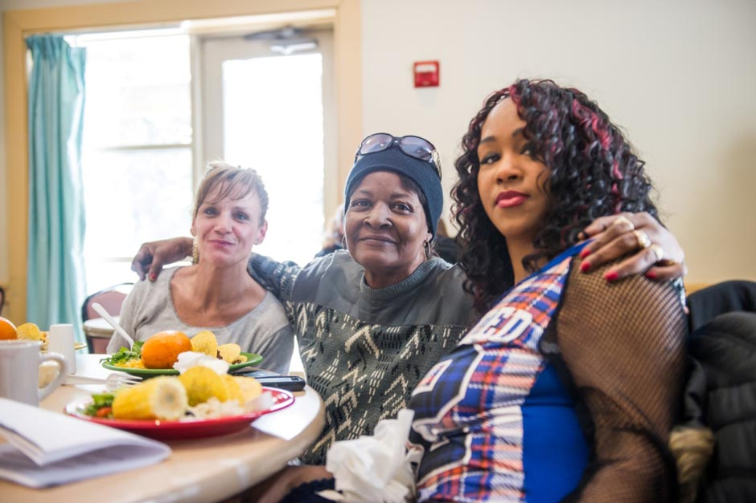
Emergency Services
Rosie’s Place offers free meals 365 days a year; a food pantry with non-perishable items and fresh produce; showers, laundry and lockers; overnight beds for up to 21 days; and providers who offer health and wellness care.

Opportunity
Women can take English as a Second or Other Language, as well as Literacy and computer classes in the Women's Education Center and find assistance with job and housing searches.

Advocacy and Empowerment
Multi-lingual Advocates assist women with short- and long-term issues, attorneys provide holistic legal services, and guests are encouraged to participate in Rosie’s Place’s diverse Arts and Public Policy activities, which can empower them to be their own best advocates.

Outreach and Stability
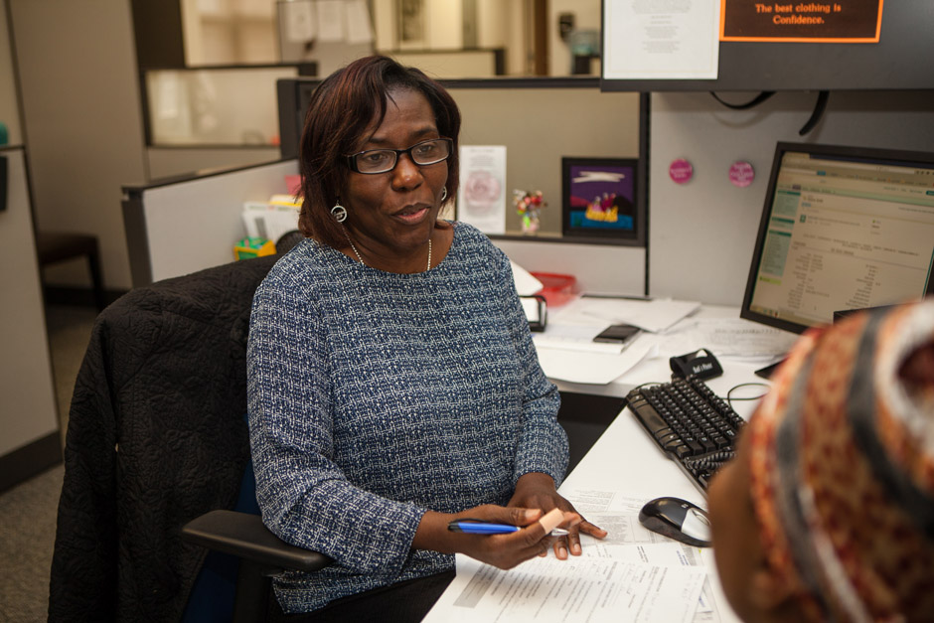
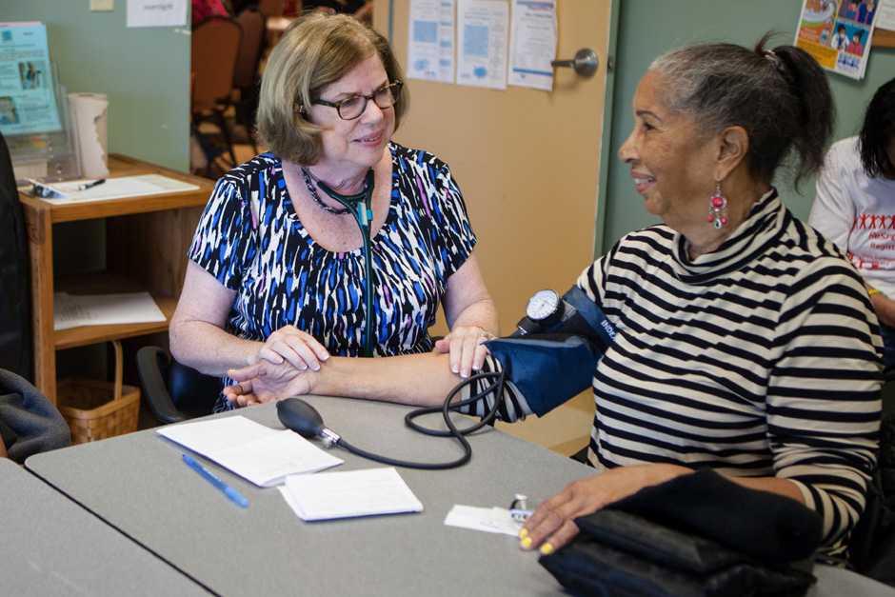
Rosie’s Place stays connected to guests by providing ongoing follow-up to newly housed guests, oversight of women who have complex physical and mental health issues, and home visits to isolated women. The organization reaches women beyond their walls through a satellite office at Franklin Field and collaborations with Boston Public Schools and Massachusetts Trial Courts.
Impact
With committed and collaborative leadership and staff and a dedicated Board, Rosie’s Place is one of the most respected, well-branded organizations in Boston. With an expansive network of staff, constituents, and people who believe change is possible and share a vision of justice, Rosie’s Place accomplished the following in FY19:

- Rosie’s Place served over 104,000 nutritionally balanced breakfasts, lunches and dinners in the warm and cheery Dining Room.
- The food pantry enabled 2,000 women per month to take home 20 to 40 pounds of foods that their families prefer and enjoy.
- Rosie’s Place’s Advocacy staff scheduled more than 15,000 appointments with guests. Advocates assist with housing, educational and employment opportunities, clothing, wellness care, transportation and emergency funds for eviction prevention and medications.
- Approximately 300 women found sanctuary in Rosie’s Place emergency housing, while advocates worked with them to find permanent homes and services they needed.
- The Housing Stabilization program worked to break the cycle of chronic homelessness. Ninety-eight percent of guests receiving monthly in-home support are able to stay housed and break the cycle of homelessness.

Throughout the pandemic, Rosie’s Place’s doors have remained open and their help, constant. Rosie’s Place has adapted their programs and services to meet the most urgent needs of homeless women with medical screenings, meals, showers and both daytime and overnight shelter. Responding to the growing hunger crisis, their Food Pantry has doubled its capacity.

Further, the organization’s remote Advocacy, Legal and Outreach programs are lifelines to women who are facing the enormous challenges of looming evictions and crushing debt as a result of the pandemic. Rosie’s Place’s team gives these women the expert help they need to remain stable. Between March and June of 2020, Rosie’s Place raised an additional $241,600 in funds to address their COVID response efforts.

“The team at Rosie’s Place is among the most committed, mission driven and hard-working staff with whom I’ve ever worked, and their dedication to our guests is evident in all they do. The longevity of so many speaks to the inclusive nature of the organization and it’s the people who work here who have allowed us to become the organization we are today.”

-Leemarie Mosca, President/Executive Director

About Philanthropy at Rosie’s Place
The fundraising program at Rosie’s Place is well established, sophisticated, and poised for additional growth. In the last five years, annual funds raised have grown from $7.4M to $11.2M, with funds coming from individuals, foundations and corporations. Rosie’s Place does not accept government funding, allowing for greater flexibility and sustainability. Instead, they rely on committed volunteers and private supporters to accomplish its effective and innovative work.

Rosie’s Place embraces utilization of metrics for all aspects of their work, including their fundraising program, which is data driven and evidence based.
About the Position
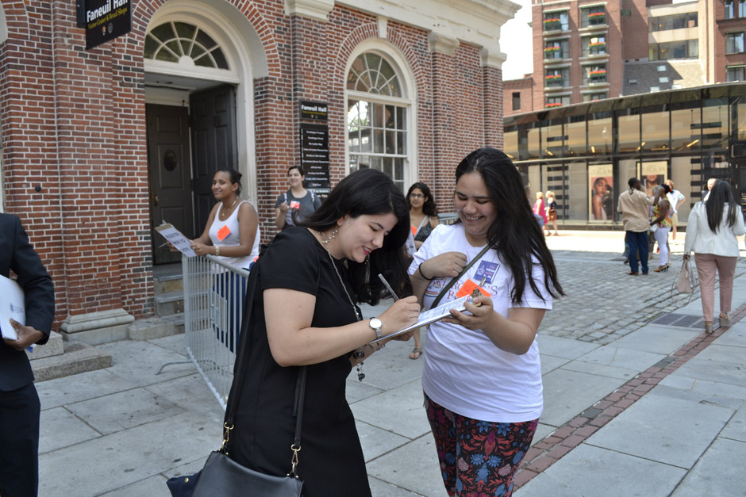
The opportunity exists now to take the Rosie’s Place fundraising program to even greater heights, specifically in the area of institutional giving. Rosie’s Place is currently raising $1.5M from grants and $700K from corporate partners and supporters annually.

Reporting to the Director of Development, the Director of Corporate and Foundation Relations is responsible for securing corporate, family and private foundation donations in support of the mission of Rosie’s Place. They will lead the implementation of best practices regarding Foundation and Corporate Relations operations within the larger Development framework and team. Additionally, they will work collaboratively with the Director of Development and Special Events Manager to lead and maintain corporate partnerships and other cause marketing opportunities.
Key Responsibilities
- Manage an annual schedule of grants that realizes $2M+ annually, including all proposals and reports.
- Steward existing institutional donors, including annual reporting, virtual, and face-to-face visits with funders.
- Maintain up-to-date records in the database (Raiser’s Edge/NXT).
- Research, identify, cultivate, and solicit new funding sources.
- Partner and communicate regularly with program staff to stay current with institutional funding priorities and new programs; serve as program liaison to the full development team.
- Oversee the identification and implementation of key external strategic partnerships, with an emphasis on building mission relationships on core new programs, including new collaborations and branches of Rosie’s Place.
- Perform any additional duties as assigned by the Director of Development.
Key Qualifications
- Strong and demonstrable commitment to social justice; ability to articulate the mission and philosophy of Rosie’s Place.
- A minimum 5 to 7 years of development experience, preferably including grant writing.
- Knowledge of funding resources and the Boston philanthropic community.
- Excellent verbal, written and problem-solving skills, demonstrated ability to expand brand awareness.
- Excellent organizational skills and the ability to prioritize tasks and work independently.
- Flexibility and the ability to work effectively in a collaborative and busy development office.
- Highly self-motivated, professional ethics, integrity, and accountability in all actions.
- Team player with positive attitude.

Work Expectations at Rosie’s Place
We are a hands-on team and seek employees who are passionate about our work and service to our community. The Director of Corporate and Foundation Relations is a 40 hours/week, exempt position and is expected to work onsite at Rosie’s Place during their work week and engage regularly with staff, guests and volunteers.

We continue to adapt to safety protocols related to COVID-19 as we understand them. For the safety of the community, Rosie’s Place employees, whether vaccinated or not, are responsible for obtaining regular COVID surveillance testing and submitting results.

It is the policy of this organization to afford equal opportunity in all aspects of employment to all persons without discrimination on the basis of race, religion, sex, gender identity and expression, sexual orientation, national origin, ancestry, ethnicity, age, handicap (disability), genetics, color, or marital status. This policy shall apply to all employees, applicants for employment, board and committee members, and volunteers and extends to all phases of employment, including recruitment, screening, referral, hiring, training, promotion, discharge or layoff, rehiring, compensation, and benefits.

Rosie’s Place strives to maintain formal and consistent procedures that provide equal employment opportunities in recruitment, selection, compensation, benefits, staff development and training, promotion, and any other conditions of employment.

Please email your cover letter, resume and existing sample of either a proposal or report to: RosiesDCFR@developmentguild.com.

Suzanne J. Battit
SENIOR VICE PRESIDENT

For more information, please visit www.developmentguild.com.
For more information about Rosie’s Place, please visit www.rosiesplace.org.

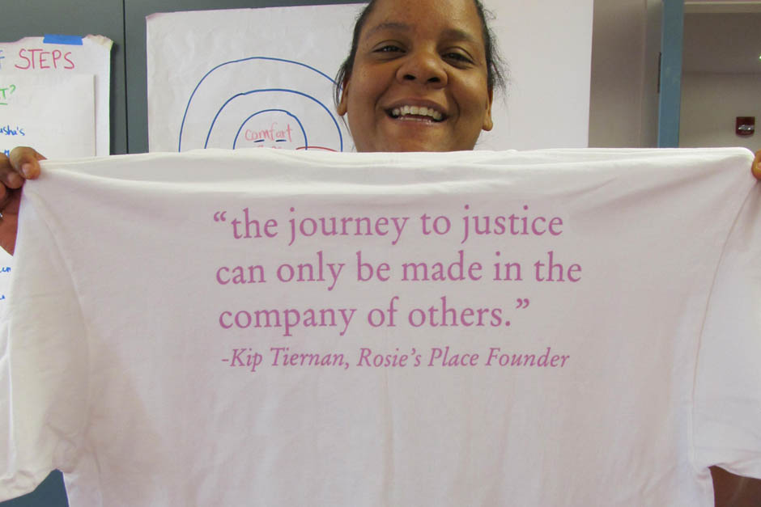
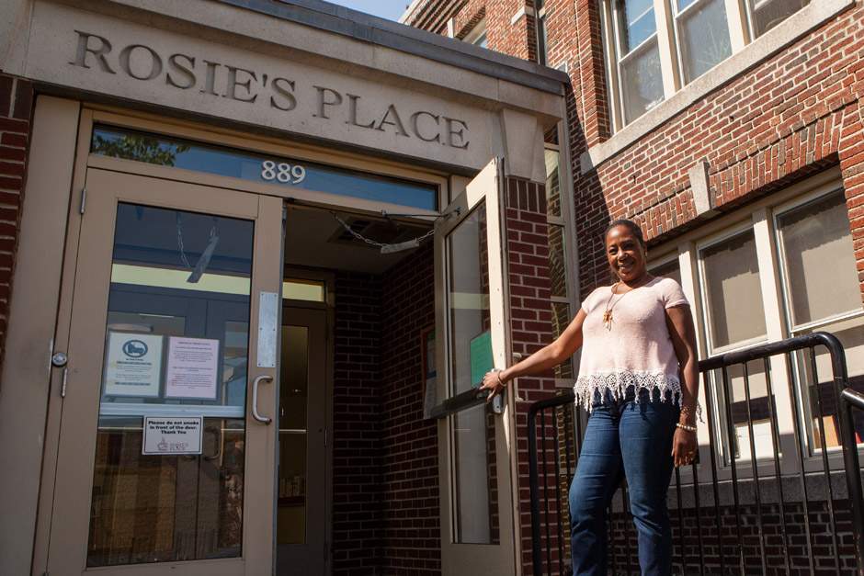

About Development Guild DDI
For 40 years, Development Guild DDI has consulted to leaders across the nonprofit spectrum. With offices in Boston and New York, we have successfully collaborated with more than 650 clients nationwide in the sectors of health & science, education, environment, the arts, and social justice. We are experts in executive search and fundraising and are at the forefront of delivering best practice in these services.

With each engagement, we work in teams tailored to a client’s particular needs, providing sector-specific intelligence, cross-sector insight, and hands-on functional expertise. We combine our perspective on nonprofit leadership with our knowledge and experience in both fundraising and executive search. This distinct perspective enables us to deliver the most strategic and measurable impact.

